**Experiment No :** 18

**Experiment name :** Write a C program to check whether a character is a vowel or not .

**Methodology :**

In this program, the isVowel function takes a character as input and converts it to uppercase using the toupper function from the header. This step is important to handle both uppercase and lowercase characters. Then, it checks whether the character is one of the vowel characters ('A', 'E', 'I', 'O', 'U') and returns 1 if it is a vowel, and 0 otherwise.

In the main function, we read a character from the user and call the isVowel function to check if it is a vowel or not. The program then prints the result accordingly.

**Flow-Chart :**

char c ;

int lowerCase_vowel , upperCase_vowel ;

**Code :**

Print vowel

Print not vowel

If alpha is a , e , i , o ,u , A, E ,I ,o,U

scanf("%c",&c);

#include<stdio.h>

int main()

{

char c ;

int lowerCase_vowel , upperCase_vowel ;

printf("Enter a alphabet : ");

scanf("%c",&c);

lowerCase_vowel = (c=='a' || c=='e'|| c=='i' || c=='o' || c=='u');

upperCase_vowel = (c=='A' || c=='E'|| c=='I' || c=='O' || c=='U');

if(lowerCase_vowel || upperCase_vowel){

printf("%c is vowel . ",c );

}

else

printf("%c in a consonant . ",c);

return 0 ;

}

**Output:**

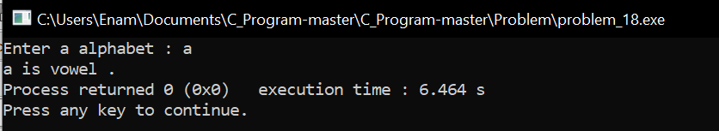

**Result discussion :**

With this program we have identified the vowels and consonants. It is a very simple program that we have defined using the OR operator.